Episode 502: The photoelectric effect

This episode introduces an important phenomenon. Light releases electrons from metal surfaces.
Lesson Summary
- Demonstration: The basic phenomenon (15 minutes)
- Discussion: Summarising the phenomenon (10 minutes)
- Discussion: An analogy (5 minutes)
- Student questions: Using the photoelectric equation. The Millikan experiment: to verify Einstein’s photo-electric relationship (30 minutes)
- Student experiment: Measuring Planck’s constant (30 minutes)

Demonstration: The basic phenomenon
Introduce the topic by demonstrating the electroscope and zinc plate experiment.
Episode 502-1: Simple photoelectric effect demonstration (Word, 36 KB) - see end of document

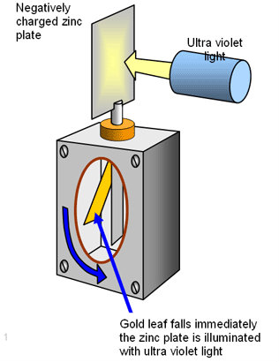
Point out to the students that the photoelectric effect is apparently instantaneous. However, the light must be energetic enough, which for zinc is in the ultraviolet region of the spectrum. If light were waves, we would expect the free electrons to steadily absorb energy from the waves until they escape from the surface. This would be the case in the classical theory, in which light is considered as waves.
However, we could wait all day and still the red light would not liberate electrons from the zinc plate.So what is going on? We picture the light as quanta of radiation (photons). A single electron captures a single photon. The emission of an electron is instantaneous as long as the energy of each incoming quantum is big enough. If an individual photon has insufficient energy, the electron will not be able to escape from the metal.

Discussion: Summarising the phenomenon
Summarise the important points about the photoelectric effect.
- There is a threshold frequency (and, hence, energy), below which no electrons are released.
- The electrons are released at a rate proportional to the intensity of the light (i.e. more photons per second means more electrons released per second).
- The kinetic energy of the emitted electrons is independent of the intensity of the incident radiation. They are emitted with a maximum velocity.

Discussion: An analogy
Try this analogy, which involves ping-pong balls, a bullet and a coconut shy. A small boy tries to dislodge a coconut by throwing a ping-pong ball at it – no luck, the ping-pong ball has too little energy! He then tries a whole bowl of ping-pong balls but the coconut still stays put! Along comes a physicist with a pistol (and an understanding of the photoelectric effect), who fires one bullet at the coconut – it is instantaneously knocked off its support.
Ask how this is an analogy for the zinc plate experiment. (The analogy simulates the effect of infrared and ultra violet radiation on a metal surface. The ping-pong balls represent low energy infrared, while the bullet takes the place of high-energy ultra violet.)
Now you can define the work function. Use the potential well model to show an electron at the bottom of the well. It has to absorb the sufficient energy in one go to escape from the well and be liberated from the surface of the material.

Units
The electronvolt is introduced because it is a convenient small unit. You might need to point out that it can be used for any (small) amount of energy, and is not confined to situations involving electrically accelerated electrons.

Potential well
It is useful to compare the electron with a person in the bottom of a well with totally smooth sides. The person can only get out of the well by one jump, they can't jump half way up and then jump again. In the same way an electron at the bottom of a potential well must be given enough energy to escape in one jump. It is this energy that is the work function for the material.
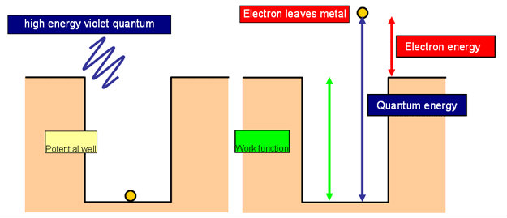
Now you can present the equation for photoelectric emission:
Energy of photon E = h × f
Picture a photon transferring energy to one of the electrons which is least tightly bound in the metal. The energy of the photon does two things.
Some of it is needed to overcome the work function Φ.
The difference is the kinetic energy of the electron when it leaves the metal.
h × f = Φ + ½ m v ²
A voltage can be applied to bind the electrons more tightly to the metal. The stopping potential V_{s} is just enough to prevent any from escaping:
h × f = Φ + e × V_{s}

Student questions: Using the photoelectric equation
Set the students some problems using these equations.
Episode 502-2: Photoelectric effect questions (Word, 42 KB) - see end of document

Episode 502-4: Student question. The Millikan experiment (Word, 51 KB) - see end of document

The Millikan experiment question may best come after
Episode 502-3: Student experiment: Measuring threshold frequency (Word, 35 KB) - see end of document

Student experiment: Measuring Planck’s constant
Episode 502-3: Measuring threshold frequency (Word, 35 KB) - see end of document

Students can measure Planck’s constant using a photocell.
(Some useful clipart is given here below).
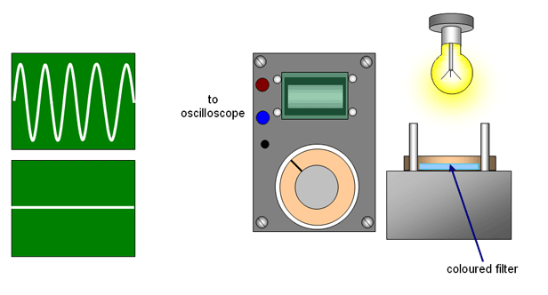

Episode 502-1: Simple photoelectric effect demonstration

Resources needed
- Gold leaf electroscope or coulomb meter
- Zinc plate attachment (sand-papered clean to remove oxidation)
- Laser (class 2)
- Mains lamp (a desk lamp is ideal)
- Ultra violet lamp with clear quartz envelope

Safety
A class 2 laser requires a warning: Do not stare down the beam.
A short-wave UV lamp must be shielded so that the UV emerges through a hole. The hole is always directed away from eyes. The presence of UV can be demonstrated by showing fluorescence of paper.

Technique
Attach the zinc plate to the top of the electroscope. (A coulomb meter can be used instead of the electroscope.)
Charge the plate negatively.
or
No effect
No effect
With U.V. leaf falls immediately
(Diagrams: resourcefulphysics.org)
Shine red laser light onto the cleaned zinc plate – no effect.
Use a mains light bulb emitting white light – no effect.
Use an ultra violet lamp – the leaf falls immediately.
Episode 502-2: Photoelectric effect questions

hf = φ + (1/2) mv² and hf = φ + eV_{s}

e = 1.60 x 10⁻¹⁹ C,
h = 6.63 x 10⁻³⁴ J s,
mass of electron = 9.11 x 10⁻³¹ kg

1 The work function for lithium is 4.6 x 10⁻¹⁹ J.
(a) Calculate the lowest frequency of light that will cause photoelectric emission.
(b) What is the maximum energy of the electrons emitted when light of 7.3 x 10¹⁴ Hz is used?

2 Complete the table.

Metal | Work Function  /eV | Work Function  /J | Frequency  used /Hz | Maximum KE of  Ejected electrons /J
Sodium | 2.28 |  | 6 x 10¹⁴
Potassium |  | 3.68 x 10⁻¹⁹ |  | 0.32 x 10⁻¹⁹
Lithium | 2.9 |  | 1 x 10¹⁵
Aluminium | 4.1 |  |  | 0.35 x 10⁻¹⁹
Zinc | 4.3 |  |  | 1.12 x 10⁻¹⁹
Copper |  | 7.36 x 10⁻¹⁹ | 1 x 10¹⁵

3 The stopping potential when a frequency of 1.61 x 10¹⁵ Hz is shone on a metal is 3 V.
(a) What is energy transferred by each photon?
(b) Calculate the work function of the metal.
(c) What is the maximum speed of the ejected electrons?

4 Selenium has a work function of 5.11 eV. What frequency of light would just eject electrons? (The threshold frequency is when the max KE of the ejected electrons is zero)

5 A frequency of 2.4 x 10¹⁵ Hz is used on magnesium with work function of 3.7 eV.
(a) What is energy transferred by each photon?
(b) Calculate the maximum KE of the ejected electrons.
(c) The maximum speed of the electrons.
(d) The stopping potential for the electrons.
Answers and worked solutions
1(a) hf = φ
hf = 4.60 x 10⁻¹⁹
f = 4.60 x 10⁻¹⁹ / 6.63 x 10⁻³⁴ = 6.94 x 10¹⁴ Hz

(b) hf = φ + (1/2) mv². (6.63 x 10⁻³⁴ x 7.30 x 10¹⁴) = 4.60 x 10⁻¹⁹ + (1/2) mv²
4.84 x 10⁻¹⁹ - 4.60 x 10⁻¹⁹ = (1/2) mv² = 0.24 x 10⁻¹⁹ J
2

Metal | Work Function  / eV | Work Function  / J | Frequency  used / Hz | Maximum KE of  ejected electrons / J
Sodium | 2.28 | 3.65 x 10⁻¹⁹ | 6 x 10¹⁴ | 0.35 x 10⁻¹⁹
Potassium | 2.30 | 3.68 x 10⁻¹⁹ | 6 x 10¹⁴ | 0.32 x 10⁻¹⁹
Lithium | 2.90 | 4.64 x 10⁻¹⁹ | 1. x 10¹⁵ | 1.99 x 10⁻¹⁹
Aluminium | 4.10 | 6.56 x 10⁻¹⁹ | 1.04 x 10¹⁵ | 0.35 x 10⁻¹⁹
Zinc | 4.30 | 6.88 x 10⁻¹⁹ | 1.2 x 10¹⁵ | 1.12 x 10⁻¹⁹
Copper | 4.60 | 7.36 x 10⁻¹⁹ | 1 x 10¹⁵ | 0

For copper 1 x 10¹⁵ Hz is below the threshold frequency so no electrons are ejected.

3
(a) 1.07 x 10⁻¹⁸ J
(b) hf = φ + eV_{s,} so φ = hf - eV_{s, so} φ = 1.07 x 10⁻¹⁸ – (1.6 x 10⁻¹⁹ x 3) = 5.9 x 10⁻¹⁹ J
(c) eV_{s} = (1/2) mv² so (1.60 x 10⁻¹⁹ x 3) = 0.5 x 9.11 x 10⁻³¹ x v²
so v² =1.04 x 10¹² and v = 1.02 x 10⁶ m s⁻¹

4 1.2 x 10¹⁵ Hz

5
(a) 1.6 x 10⁻¹⁸ J
(b) (1/2) mv² = 1.x 10⁻¹⁸ J
(c) v² = 1.1 x 10¹² so v = 1.1 x 10⁶ m s⁻¹
(d) eV_{s} = (1/2) mv² so eV_{s} = 1.00 x 10⁻¹⁸ and V_{s} = 0.63 V

Episode 502- 3: Measuring threshold frequency

Use a white light source and a set of coloured filters to find the threshold frequency, and hence the work function, of the photosensitive material in a photocell. This may well be a standard piece of kit in your school or college. Use a spreadsheet to plot and analyse a graph of your results.

This experiment uses a photocell to investigate the photoelectric effect. Light of various frequencies is incident on the cell and photoelectrons are emitted and then form an electric current. A white light source is shone through various coloured filters to produce a series of different frequencies of light falling on the photocell. The current of photoelectrons produced in the cell maybe amplified internally and is measurable on the ammeter. Otherwise an amplifying picoammeter is needed.

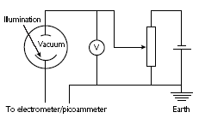
The potential divider provides an adjustable voltage. The incident frequency, threshold frequency, and stopping potential are related by the following equation:
hf =eV + hf_{o}

Procedure
For each coloured filter, adjust the potential divider until the stopping potential has been reached.
Record the stopping potential and the wavelength of light transmitted by the filter. Select the middle of the range as the transmitted frequency.
NB: the filter might have written on it the range of wavelengths it transmits measured in
Enter your results of frequency and stopping potential on a spreadsheet and plot a graph of frequency f versus stopping potential V.

Use your graph to determine the value of the threshold frequency f and hence calculate the work function φ. Express your result in J and in eV.

Estimate the uncertainties in your measurements of V and in the values of f that you have used. Use these estimates to add error bars to your graph and hence estimate the uncertainty in your values of f₀ and φ.
Decide how you could use your graph to determine the value of Planck's constant if you knew only the value of e and not h.

Data
Planck constant h = 6.60 x 10⁻³⁴ J s
electron charge e = 1.67 x 10⁻¹⁹ C
speed of light c = 3.00 x 10⁸ m s⁻¹
1eV = 1.67 x 10⁻¹⁹ J

Practical advice
This section revisits ideas about charge, energy and potential difference and introduces the idea of a stopping potential in order to measure the kinetic energy of photoelectrons. Students need to realise that, if a charged particle is accelerated by a pd, energy is transferred to it, whereas if it moves the other way, it loses kinetic energy, and that the two situations are the exact reverse of each other. Students should appreciate that the work function represents the minimum amount of work that an electron must do in order to get free and that the expression for kinetic energy represents the maximum possible kinetic energy of the photoelectron. This energy is only attainable if the energy transfer from photon to electron is 100% efficient and there is no energy dissipation, e.g. due to heating.

This is quite a demanding activity, as it involves a relatively complicated and unfamiliar set-up. Make sure students appreciate the use of the potential divider, (as in Episode 118 The Potential Divider).

In analysing their results, students need to plot a graph and determine the y-intercept. Students will have met graphs of the type y = mx + c before but still might not be very confident in using them, this might need some discussion. We recommend using a spreadsheet graphing package here. Students should also take account of experimental uncertainties; the most significant is likely to be in the frequency, as the filters available do not have a very definite cut-off wavelength. There might also be some uncertainty in deciding exactly the pd at which the photocell current drops to zero.

Einstein's ideas
Albert Einstein explained the photoelectric effect in a paper published in 1905. It was the second of five ground-breaking papers he wrote that year. In the first paper, Einstein explained the mysterious Brownian motion of particles contained in pollen grains as due to the random impact of much smaller particles. This work led to the acceptance of the molecular or atomic nature of matter, which until then had been quite speculative. Einstein's third paper that year is now his most famous. Here Einstein introduced his Special Theory of Relativity which, in a later paper, led to probably the most famous equation in science: E=mc², which describes the equivalence of mass and energy. But it was Einstein's second paper, that contained his work on the photoelectric effect, that at the time was the most revolutionary of the three, and it was for this work that Einstein was eventually awarded the Nobel Prize, in 1922. (The Nobel Committee works somewhat more slowly than the speed of light!) In this paper Einstein broke away from the idea that light (electromagnetic radiation) is continuous in nature and introduced us to the idea of the quantum (plural quanta) or photon as a `packet' of light. (The term quantum is used for any packet of energy, while a photon is a quantum associated with electromagnetic radiation.) The wave model of light had been fairly conclusively established a century earlier, mainly due to the work of Thomas Young, who demonstrated and explained interference patterns. But the wave model cannot explain the photoelectric effect; Einstein realised this and took the bold step of putting forward a completely different model in order to explain the following experimental results:
- for any given metal, with radiation below a certain threshold frequency no electrons are released even if the radiation is very intense;
- provided the frequency is above the threshold, some electrons are released instantaneously, even if the radiation is very weak;
- the more intense the radiation, the more electrons are released;
- the kinetic energy of the individual photoelectrons depends only on the frequency of the radiation and not on its intensity.

Einstein was the first to use the equation E = hf to explain the photoelectric effect. It is known as the Planck equation, and h is called Planck's constant, because Max Planck had already proposed that when electromagnetic radiation was absorbed or emitted, energy was transferred in packets. That work earned Planck the 1918 Nobel Prize.

External references
This activity is taken from Salters Horners Advanced Physics, section DIG, activity 30
and the Einstein notes above from Salters Horners Advanced Physics, section DIG additional sheet 11
Episode 502- 4: The Millikan experiment to verify Einstein’s photo-electric relationship.

The photoelectric effect was – well known by the end of the 19th century. Its explanation was one of Einstein’s first applications of his photon model for light. He devised an equation relating the energy of the photoelectrons to the frequency of the light and the work function of the metal used. In 1916, American physicist Robert Millikan completed some experiments that tested Einstein's equation. Though Millikan had been firmly against quantum theory, the results convinced him that Einstein was right.
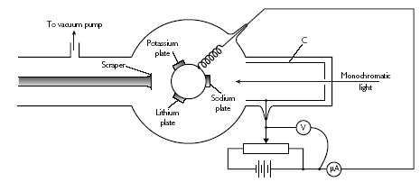
In Millikan's photoelectric apparatus, monochromatic light was incident on each of the newly-cleaned metal plates in turn. The resulting photoelectrons were collected by electrode C and flowed, via the variable resistor and microammeter, back to the plate assembly. By adjusting the potentiometer, Millikan found the potential difference that was just large enough to stop the electrons moving round the circuit. For each metal, he used radiation of several different frequencies, noting the `stopping voltage' for each. This graph shows some of his results for sodium.
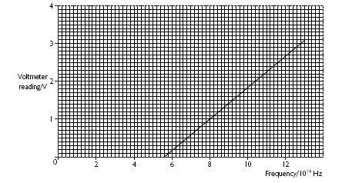
(a) Use the graph to find the threshold frequency for sodium.
(b) Calculate the work function for sodium using your answer to (a). h = 6.63 x 10⁻³⁴ J s.
(c) Use your answer to (b) to find the maximum kinetic energy of photoelectrons emitted from sodium when the frequency of the incident light is 10 x 10¹⁵ Hz. Give your answer in joules and in electronvolts. e = 1.6 x 10⁻¹⁹ C

External reference
This activity is taken from Salters Horners Advanced Physics, section DIG, additional sheet 13

Answers and worked solutions
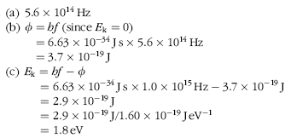

External reference
Answers and worked solutions are taken from Salters Horners Advanced Physics, section DIG, additional sheet 14

